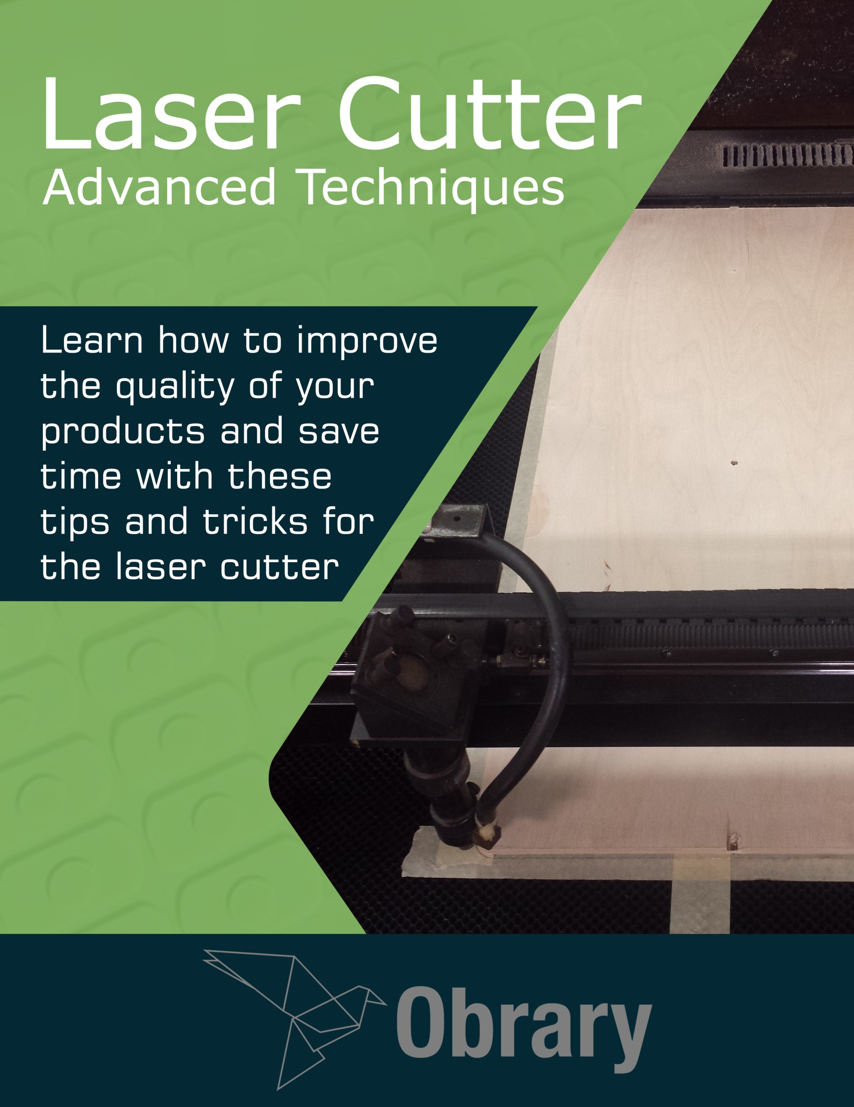

Contents

Test Cuts 1

Tape Squares 3

Living Hinges 6

Living Hinge Projects 9

Application Tape 14

Cardboard Jigs 15

Engraving Mirrored Acrylic 21

Making City Maps with a Laser Cutter 25

About Obrary 36

## Version

This document was last updated September 4, 2016.

## License

This eBook is distributed under the Creative Commons BY-SA license.



# Test Cuts

As you use the laser more, you'll need to adjust the speed and power settings frequently. Here's a method for determining the optimal settings.

There are many variables at play that you'll need to respond to. These variables include:

* The material that you are using. Each type of material responds differently to the laser.
* The condition of the material that you are using.
* The thickness of the material you are using.
* Age of the laser tube. Laser tubes have a lifespan. And their power declines over that lifespan.
* The machine that you are using. Even the exact same machines sitting side by side, will have different performance. So treat each machine uniquely.
* The lens that you are using.
* The cleanliness of the lenses and mirrors. As a laser gets used, there is a lot of smoke as material gets vaporized. This smoke becomes residue on the lenses and mirrors. As it builds up, the laser losses power.
* The weather. Changes in temperature and humidity have an impact on the laser.

So with so many variables, you really should calibrate your laser every time you use it. Calibration is simple - you just to a quick set of test cuts. Here's how it works. You want to do a series of cuts at different speeds to determine which speed is the best for this material on this laser cutter on this day. Here's a screenshot of the test file in laser software.

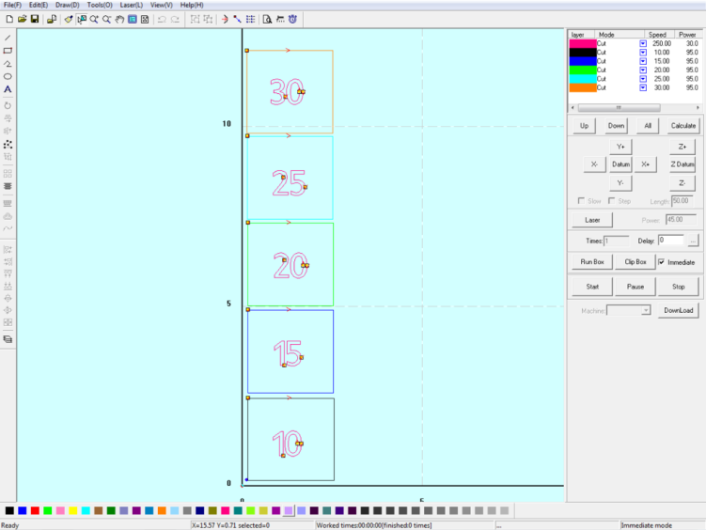

Test cuts configuration

It’s just a series of small squares cut at different speeds. The speed is written in each square. Here's what it looks like when run on 1/4" maple plywood.

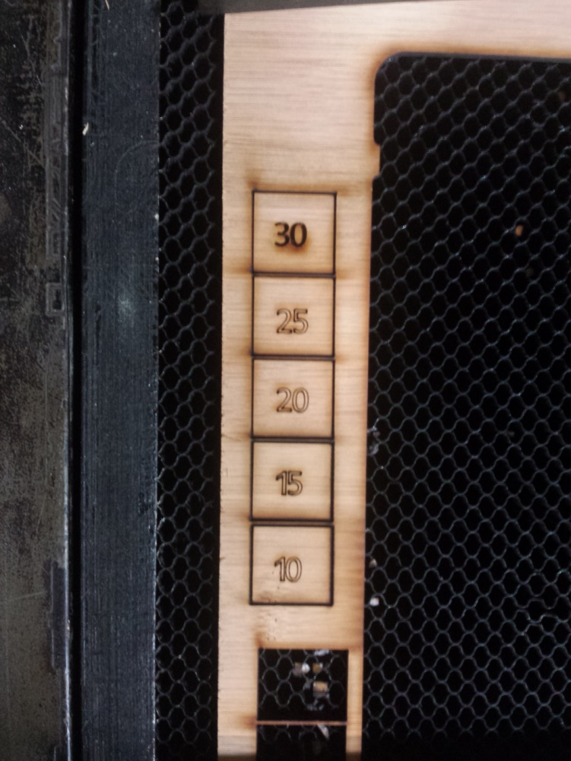

Test cuts in 1/4" maple plywood

After the laser has finished, see which of the squares you can remove from the material because the cut went all of the through. The fastest speed to cut all of the way through is the setting you want to use. You can also use the numbers to test settings for score lines and engraving. In the photo above the 30 was engraved while the other numbers were done using score lines.

Following this procedure every time you use the laser will improve your overall quality. And you'll save time as your cuts will more consistently work when the settings are calibrated.

# Tape Squares

When working on the laser, sometimes you need help in lining up your material. Here's a way that can ensure your material is lined up square in the laser bed.

To start the process, put the tape down on the laser bed in an L shape.

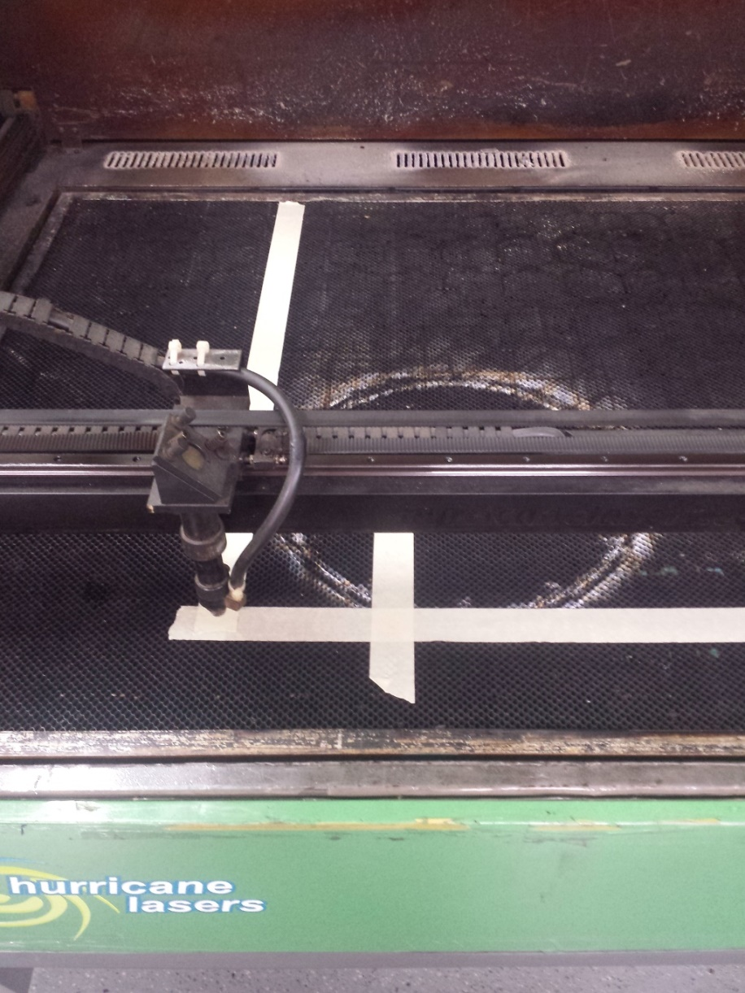

Tape in an L

With your laser software, cut two perpendicular lines in the tape. Tape is a relatively soft material. So to cut line, you'll need low power and high speed. Now these lines are in alignment with the laser.

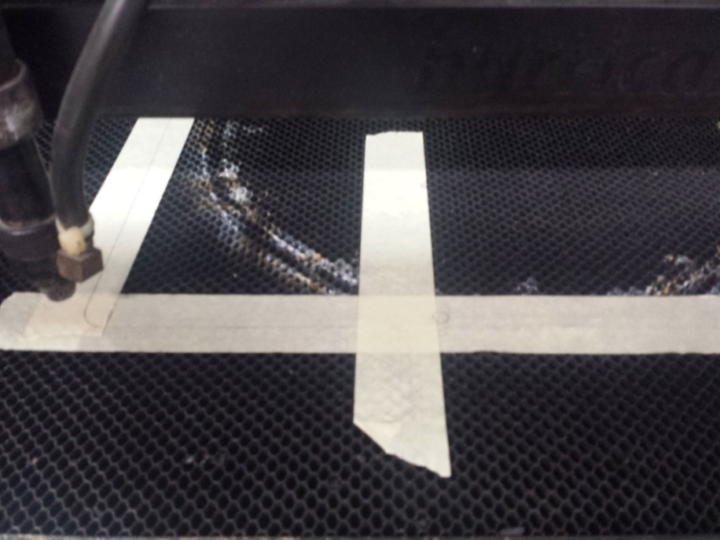

Cutting lines in the tape

Using the lines, set your material down. Your engraving will be square on your material.

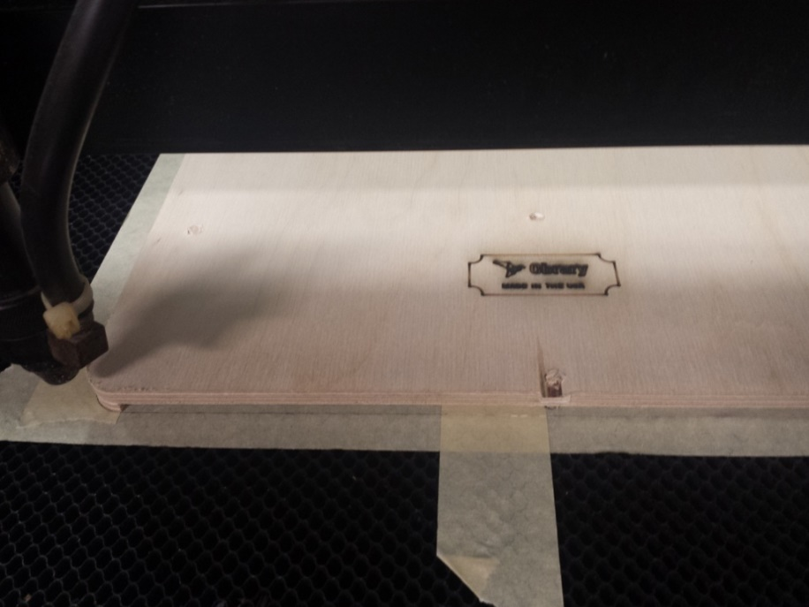

Line your material on the lines

# Living Hinges

Living hinges are fascinating to most people. It’s a technique that allows you to bend what is normally a flat and rigid material. With living hinges you can bend plywood, acrylic and many other materials. Living hinges can be used to make hinges which allow something in your product to bend. And they can also be used to create a fixed curved material out of a sheet.

Here’s a photo of a living hinge so you can picture what it looks like as we discuss them.

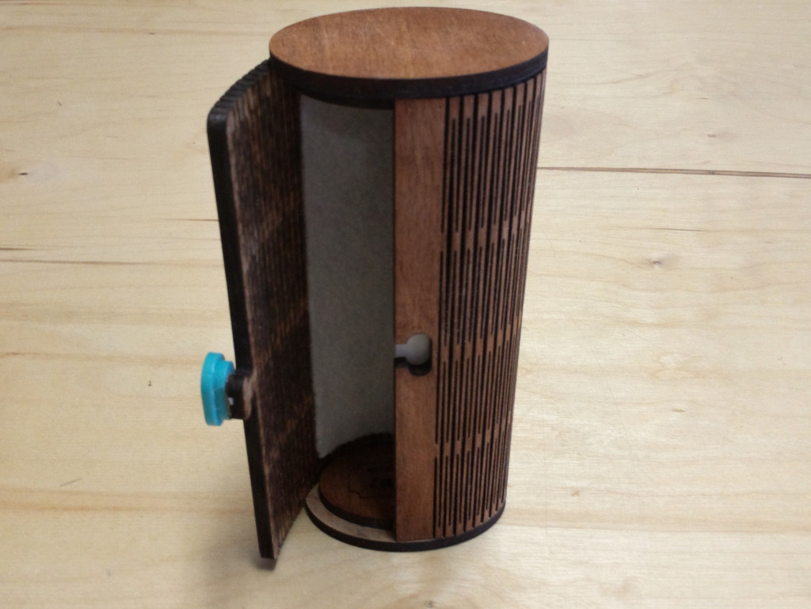

Glasses Case – a 360 degree living hinge

On Obrary, there are a number of products for the laser cutter that incorporate a living hinge into the design.

## What is a Living Hinge?

Wikipedia defines a living hinge as:

A living hinge is a thin flexible hinge (flexure bearing) made from the same material as the two rigid pieces it connects, rather than cloth, leather, or some other flexible substance. It is typically thinned or cut to allow the rigid pieces to bend along the line of the hinge. The minimal friction and very little wear in such a hinge makes it useful in the design of microelectromechanical systems, and the low cost and ease of manufacturing makes them quite common in disposable packaging.

When we use living hinges on the laser cutter, the application is a bit more specific. Lasered living hinges are when a repeating pattern of cuts are applied to sheet material to allow the piece to bend.

## How living hinges work

Here’s an example of a common living hinge pattern:

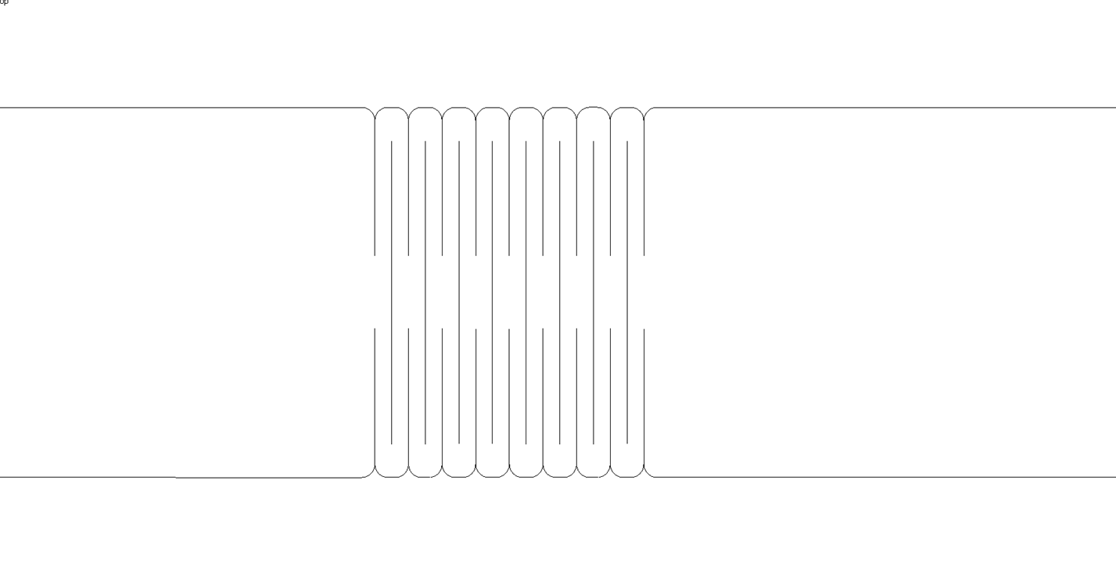

Common Living Hinge Pattern

Essentially, what is happening is that the pattern is cutting the material into long thin strips that are still connected together. If the strips are long and thin enough, they can rotate a little bit. If there is a series of strips, each of these small rotations adds up to a larger bend in the material.

Here’s an [article from Deferred Procrastination](http://www.deferredprocrastination.co.uk/blog/2011/laser-cut-lattice-living-hinges/) that explains the how of living hinges in a little more scientific detail including equations.

## How they break

Living hinges can be quite durable, but they are not perfect. Here’s some common ways that they break:

* **Pulling apart**. The easiest way to break a hinge is just by pulling it apart.
* **Over bending**. Hinges will break from over bending. This can be from bending it in too tight of a radius or from repeatedly bending to the point of breaking.
* **Inconsistency of material**. A common material used when making living hinges is plywood. Plywood is not as consistent as some materials. It is subject to imperfections like voids and area of increased density, like knots. Living hinges work best in areas of consistency as each strip in the hinge needs to act the same way. So imperfections cause the hinge to break more easily. Sometimes the first bend in a new hinge will uncover an imperfection and the hinge will break immediately.

## Tips and Tricks

As it is easy to break a living hinge by pulling it apart, one best practice is to prevent the hinge from be pulled. One way to do this is by applying adhesive backed felt to the hinge. This was done in the glasses case shown above.

As the laser is cutting material, it is putting a lot of heat into the material. When making normal cuts that are spaced far apart, this is not much of issue. But living hinges are spaced closely together. This can overload the material with heat and cause excessive melting in the case of acrylic or spontaneous combustion in the case of wood. One way to prevent this is to make the hinges with cuts that are done at lower power and slower speed.

MDF is a great material for living hinges. MDF is much more consistent than plywood. So each strip of the hinge is the same and overall, the hinge performs better and lasts longer.

# Living Hinge Projects

Here's a collection of the best laser cut projects that use living hinges.

## Living Hinge Swatches

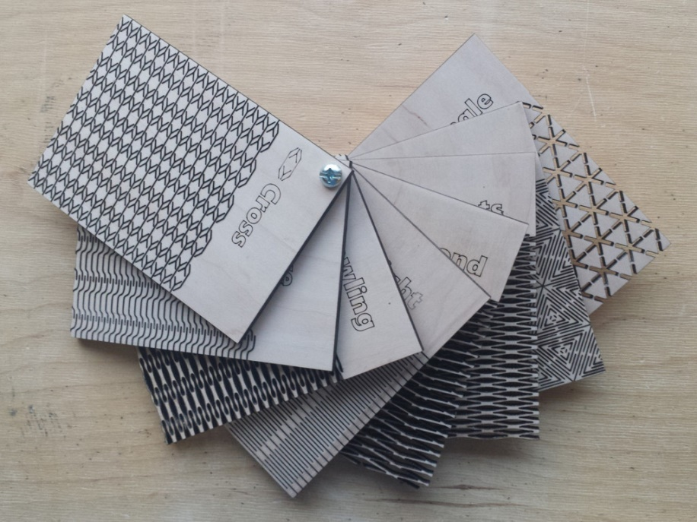

<http://obrary.com/products/living-hinge-patterns>

The living hinge swatches let you test different patterns in any material. This way, you'll be able to see if any given material will work on with a living hinge design.

### Material

You can use any material with the living hinge swatches. Test many materials and see how different ones respond.

## Business Card Box

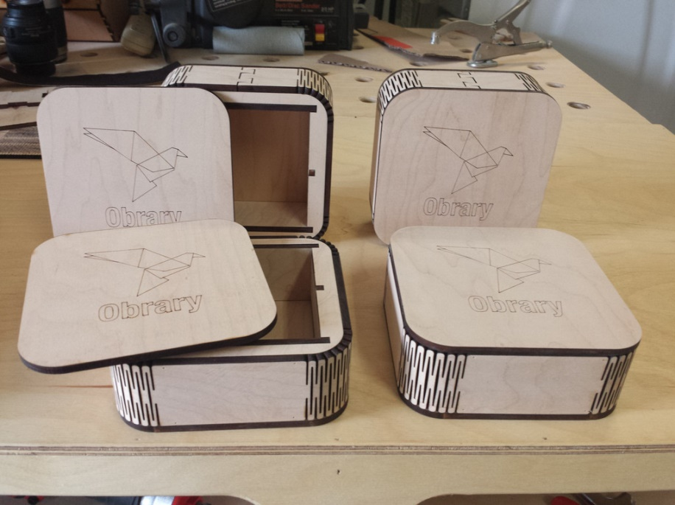

<http://obrary.com/products/business-card-box>

The business card box makes for a great gift. You can engrave a company logo and/or person's name on the box. This box uses living hinges to create appealing round corners.

### Material

The business card box is made from 1/4" maple plywood.

## Glasses Case

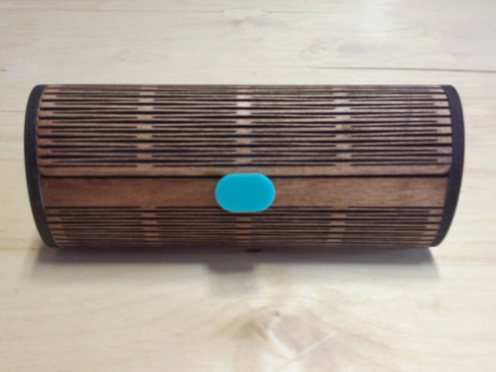

<http://obrary.com/products/sunglass-case>

The glasses case takes a sheet of living hinge and bends it 360 degrees into a tube that holds your glasses.

### Material

The glasses case is made from 1/4" maple plywood. Be warned though. Due to inconsistencies and imperfections in plywood, these complex living hinges may break on their first use.

## Mini Wood Purse

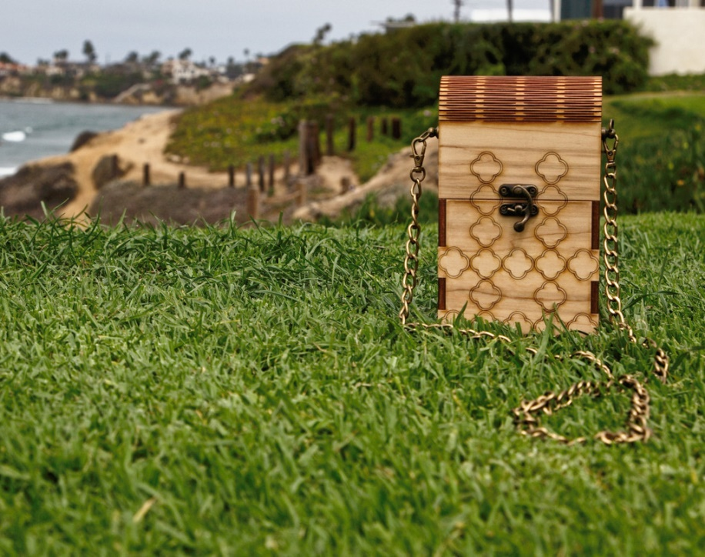

<http://obrary.com/products/mini-wood-purse>

The mini wood purse uses the living hinge on the cover of the purse. Matched with the right hardware, it makes a truly distinctive purse.

### Material

The mini wood purse is made from 1/4" maple plywood.

## Folding Notepad Booklet



<http://obrary.com/products/folding-notepad-booklet>

The folding notepad booklet comes in different sizes to hold different sized notepads. It has a clip also cut from bamboo that holds the notepad in place. Add a logo and / or name for a great personalized gift.

### Material

The folding notepad booklet is made from 1/8"bamboo plywood.

# Application Tape

Application tape is great tool to use when working with wood on the laser cutter. It reduces the amount of cleanup and sanding that is need after cutting wood on the laser cutter. Here are some best practices.

Acrylic comes with protective sheet of paper or plastic on each side. This sheet protects the acrylic from charring and residue when cutting and engraving it on the laser cutter. Once the laser work is done, you just peel the protective sheets off the acrylic and very little additional clean-up is needed. Application tape does the same thing for wood.

Application tape is not very sticky, like painter's tape. But it comes in much wider rolls. You can get it in a variety of widths for 12" to 36". You can find application tape at your local sign shop supply store.

Living hinges have a lot of cut lines which increases the amount of charring. This test is the same sample print with and without application tape. The left piece had application tape covering it. The right did not. Neither has been sanded.

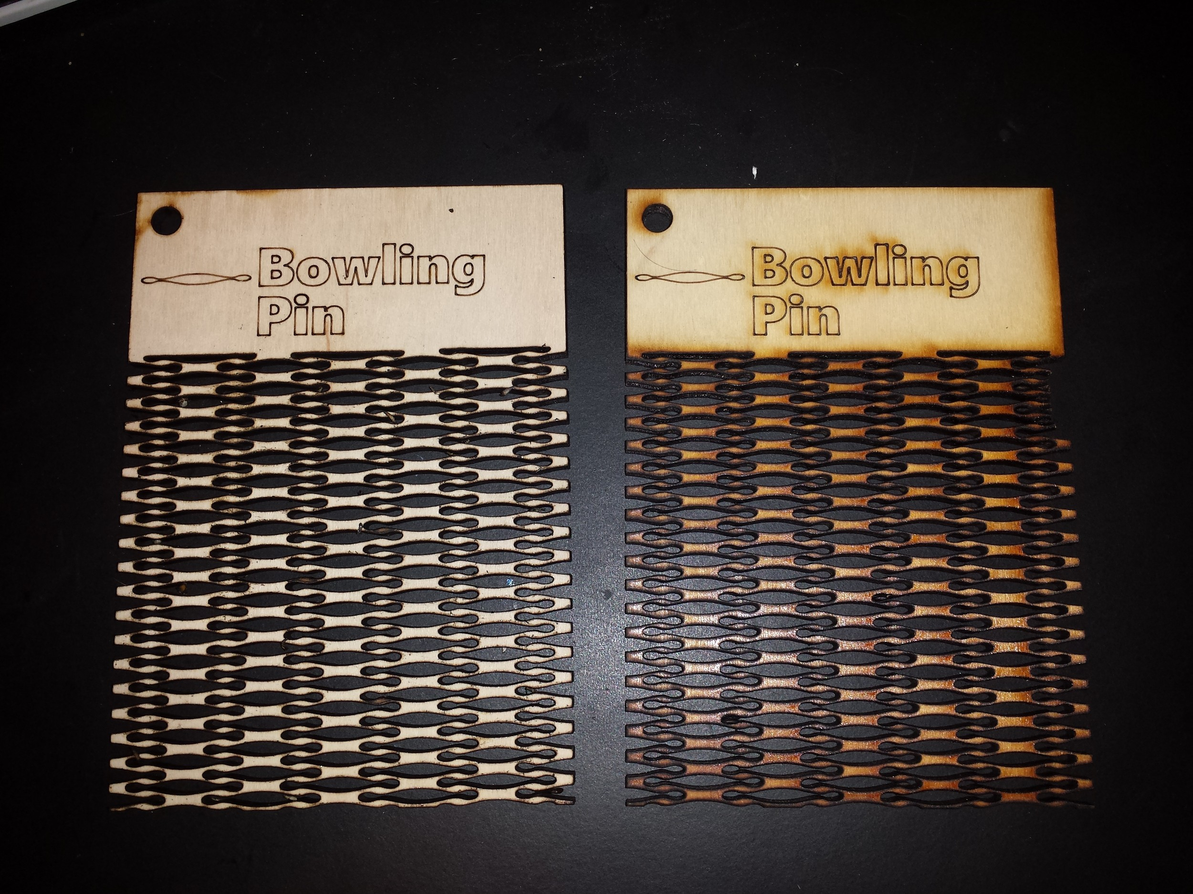

The same piece cut with and without application tape  
Product design - <http://obrary.com/products/living-hinge-patterns>

Now the application tape obviously keeps the wood cleaner, so that there is less sanding to be done. One thing to work on with the application tape is applying it as smoothly as possible to the material you are covering. Any bubbles in the tape on the material will pocket material from the lasering and will be an area of increased charring. Also, the tape can be quite a bit of an effort to take off. Especially in some of the finer lined living hinges. But the reduction of post-processing work outweighs the additional work of peeling the application tape off.

# Cardboard Jigs

When working on the laser cutter, cardboard jigs are great tool to improve the quality of the work. Scenarios where you would want to use a cardboard jig include:

* When engraving double sided projects
* When engraving an object that was not cut on the laser.

This post provides step-by-step instructions on how to use cardboard jigs for both of these scenarios.

## Engraving Double Sided Projects

When engraving a product only on one side, the engraving is done at the same time the product is cut on the laser. But when there is engraving on both sides of the product a new problem is surfaced. That problem is how to line up the now cut product so that the engraving on the second side gets properly placed. This is where jigs come into play.

First thing is to decide which side to engrave while cutting and which side to engrave in the jig. In this example, one side is the person's name and the other side is the team name. It's easier to use the jig to engrave the same design into a number of same shaped pieces. So the first side will cut the pieces with all of the unique names. Here's what the DXF looks like.

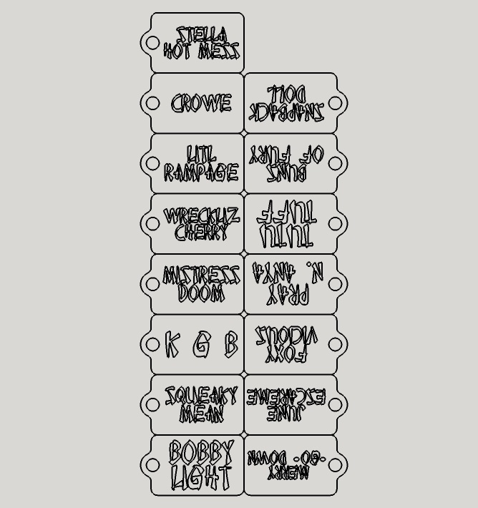

The front side DXF

And here's the front side of parts freshly off of the laser. They were cut and engraved in one job. By the way, you can see that application tape should have been used to prevent charring.

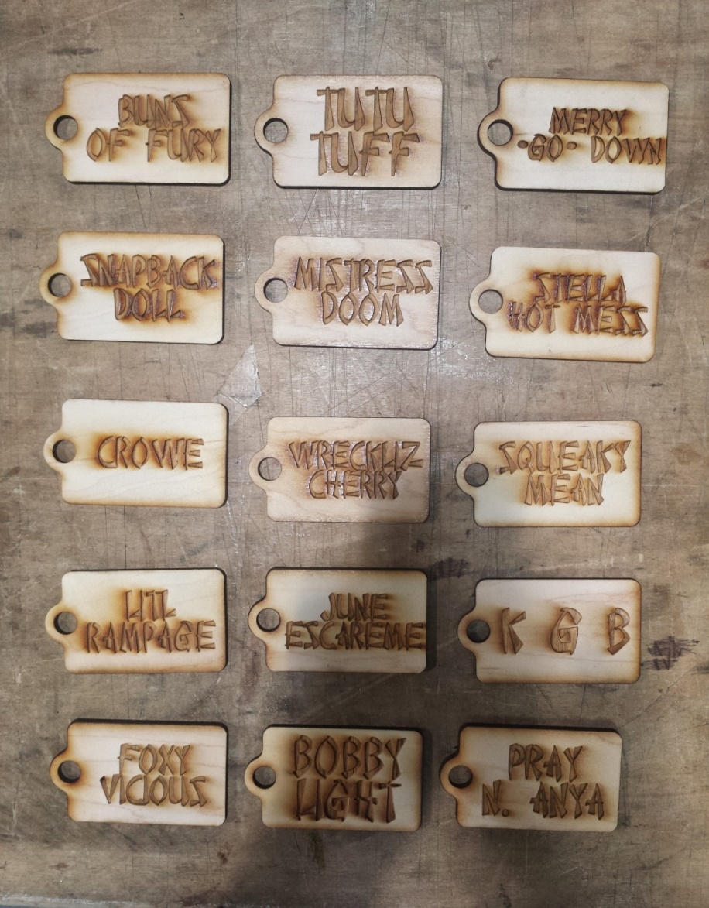

Front sides of the pieces fresh off of the laser

Then the next step is to create the DXF for the flip side. It looks like this. If you are going to engrave these one at a time, your DXF file can have just one product. If you to engrave more than one at a time, you would place more than one copy of the product in the file.

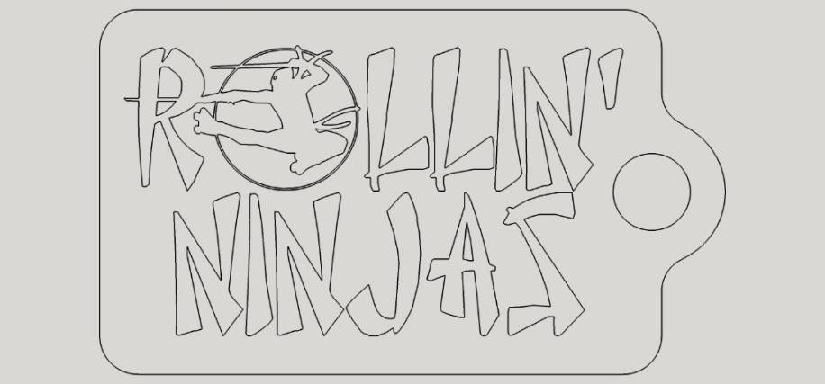

The backside DXF

To create the jig in cardboard, you just need to cut the cardboard with the outside edge line of the DXF above. Make sure the cardboard is weighted down so that it will not move at all as you add and remove pieces to be engraved.

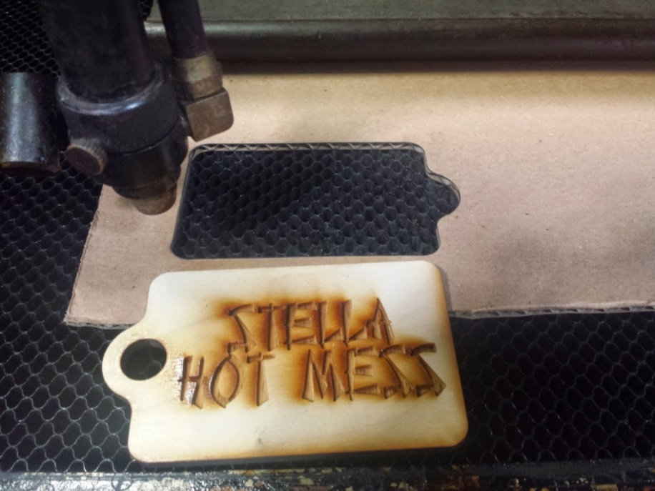

Cardboard Jig in the Laser

Then in your laser cutter software, turn off the cut line for the outside border and turn on your toolpaths for the interior objects to be engraved. Place the object into the jig and run. Because the cardboard has some thickness to it, you don't need to spend anytime lining the object up. Just drop the pieces into the cardboard hole and start the laser.

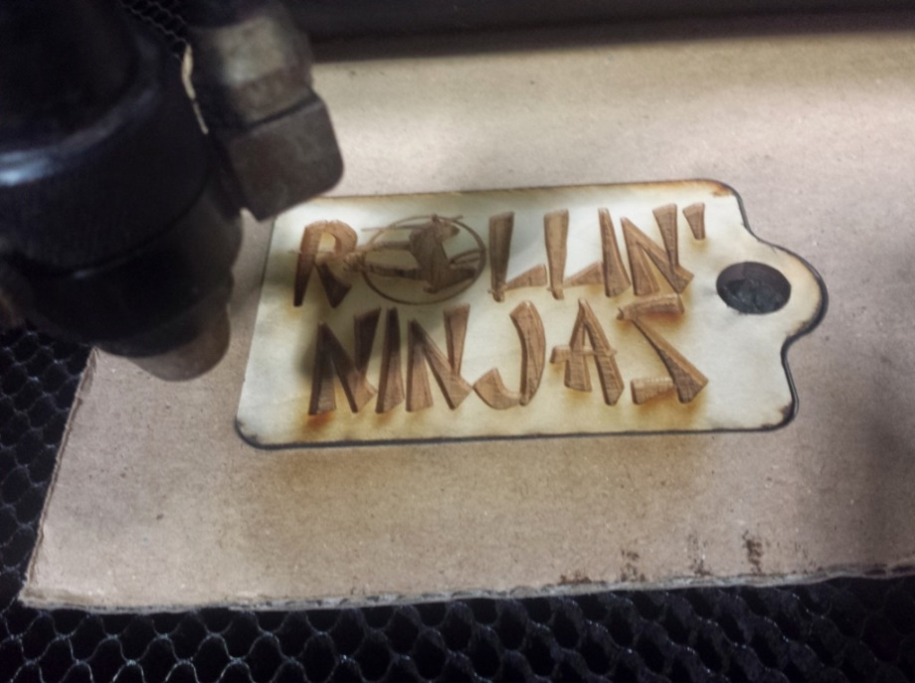

Engraving the Back Side in the Jig

And because the second side is the same for all tags, you can swap the engraved piece out and put a new blank in to get through the stack of pieces quickly.

## Engraving an Object that was not Cut on the Laser

And here's another jig example. This one is for a piece that was milled from 1/2" birch on the CNC router. Then a logo is engraved onto the piece on the laser cutter. You can use the same steps for the second side in the above example.

* create one file with both the outline of the product and the vectors to be engraved
* place the cardboard in the laser and weight it down so that it will not move
* cut the outline of the product out of the cardboard
* place the product into the jig
* reload the file onto the laser with the outside cut turned off and the engrave vectors turned on
* engrave the product

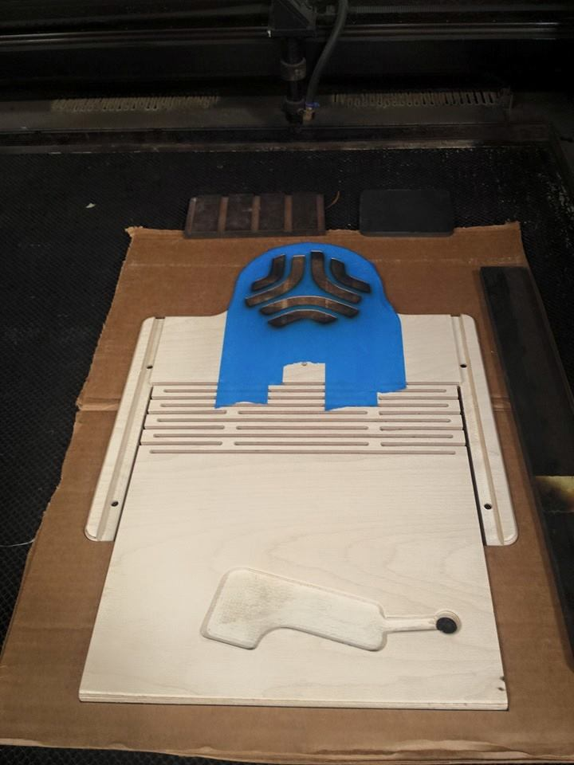

Engraving a Product not Cut on the Laser

# Engraving Mirrored Acrylic

Mirrored acrylic is a great material to make fun products. As the name implies the acrylic sheet acts as a mirror. It’s made essentially by taking a normal sheet of acrylic and applying a mirror coating to one side. The mirror surface faces the acrylic, so the mirror is protected by the acrylic sheet. Here’s a sample of what it looks like.

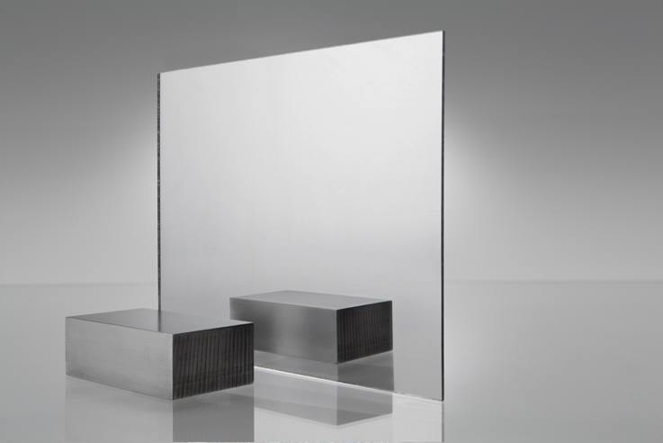

Mirrored Acrylic

Here’s how to engrave mirrored acrylic.

The first step is to decide which side to engrave. You can engrave from the top (clear) side or from the bottom (mirrored) side. Here’s a sample done each way.

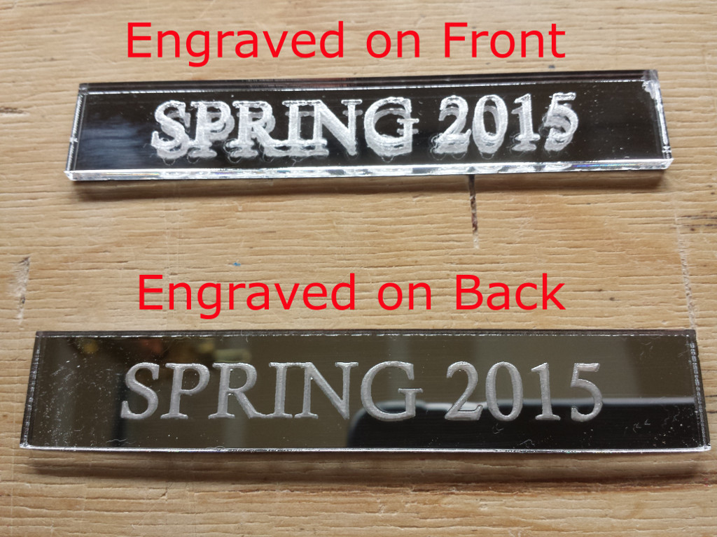

Engraving from both sides

When the engraving is on the top, the mirror surface is untouched. So the mirror reflects the engraving. This makes the engraving seem to float on the top with a doppelganger of the engraving in the mirror. It’s a confusing image to look at. It makes the engraving had to make out. Engraving on the backside is much more appealing and the recommended method.

One thing to remember when you are engraving on the back side is that your image must be flipped or mirrored, so that is shows properly from the front.

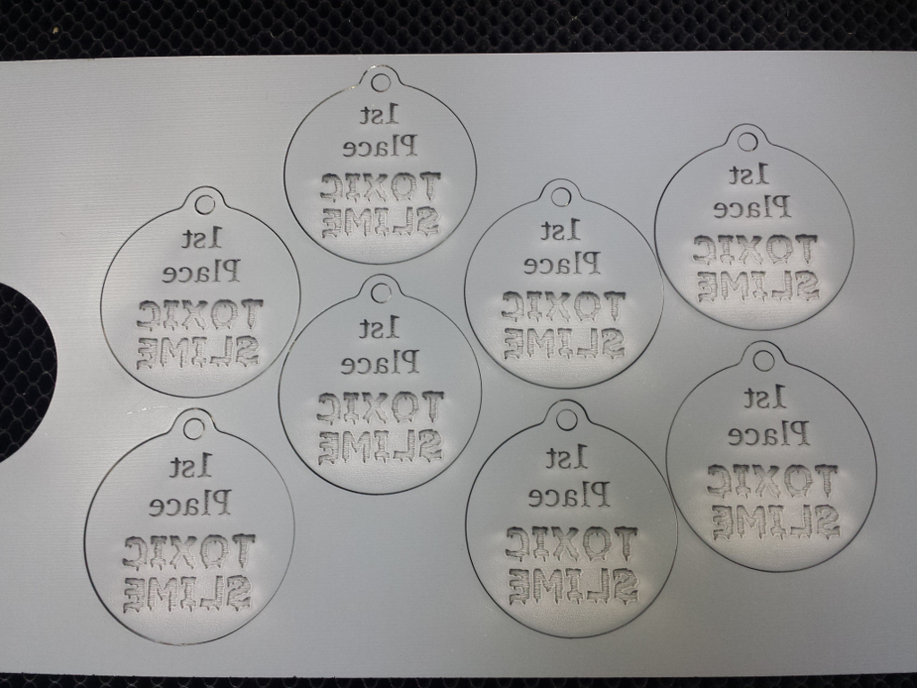

Flipped text engraved from the back

The result is very shiny, great looking items.

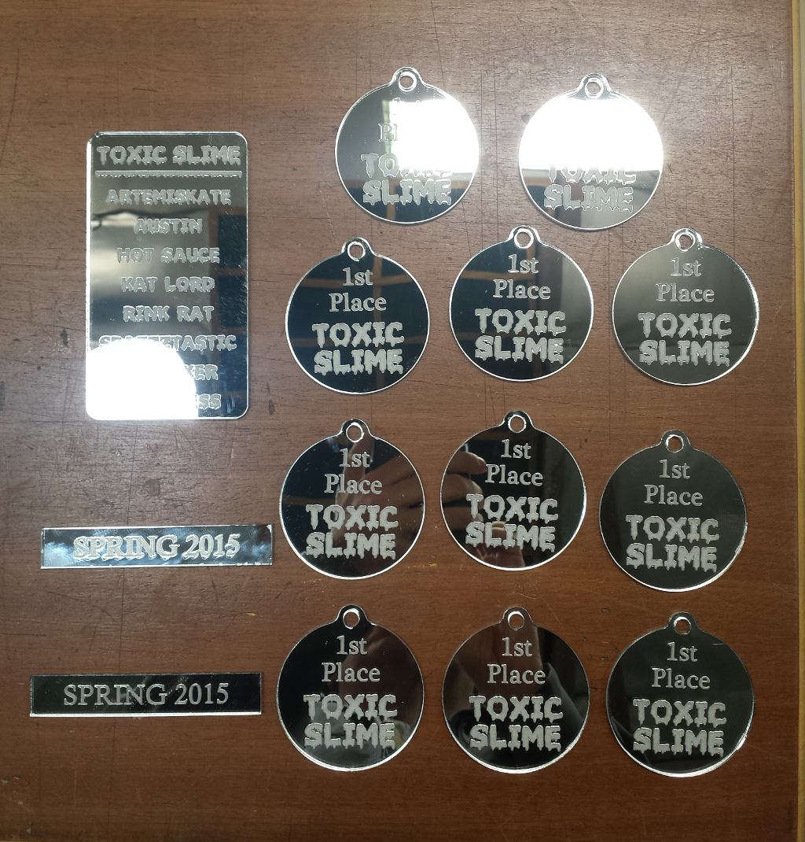

Final products from mirrored acrylic

# Making City Maps with a Laser Cutter

Everyone who sees a map made by the laser for the first time is very intrigued. The detail in them is amazing. Here you will learn how to create these maps.

## The Easy Way

The easiest way to create a map is to use an existing design. At Obrary, there are designs that you download for free and make. Here is a link to them <http://obrary.com/collections/maps>.

## The Hard Way

But there is not yet a pre-made design for every location. And even if there is, you may want yours to look different from the existing ones. So here are the end-to-end instructions for creating maps for the laser cutter. Warning: there are a lot of steps here.

The first thing you will need is map (also called GIS) software and data. Fortunately, both of these are available for free.

* **Software**. The map software is called TileMill and you can get it at <https://www.mapbox.com/tilemill/>.
* **Data**. Open Street Map is an open source data repository for map data. Mapzen hosts extracts of the data broken out by major metropolitan areas. You can find them at <https://mapzen.com/data/metro-extracts>.

So to get started, install Tilemill on your computer. Then jump over to Mapzen and download the data files for your location. Mapzen gives you multiple options for data formats. You want the SHP files.

SHP files are also called Shapefiles. Here's Wikipedia explanation of the format. "The Shapefile format is a popular geospatial vector data format for geographic information system (GIS) software. It is developed and regulated by Esri as a (mostly) open specification for data interoperability among Esri and other GIS software products. The shapefile format can spatially describe vector features: points, lines, and polygons, representing, for example, water wells, rivers, and lakes. Each item usually has attributes that describe it, such as name or temperature."

SHP files also reference other files types that you'll see in data file download. These will include .shx, .dbf and .prj.

The data files will consist of multiple SHP files. Each SHP file represents a different type of content. You'll be able to add the types of content that you want for your maps.

So, now that you have TileMill installed and your SHP format data files for your location, the next step is to open TileMill and create a new project.

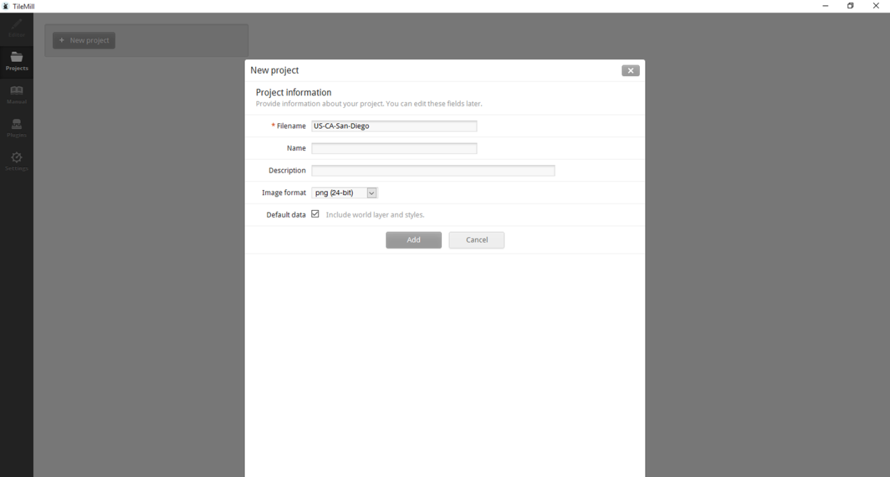

Now, you should have a new project with a basic outline of the world like this.

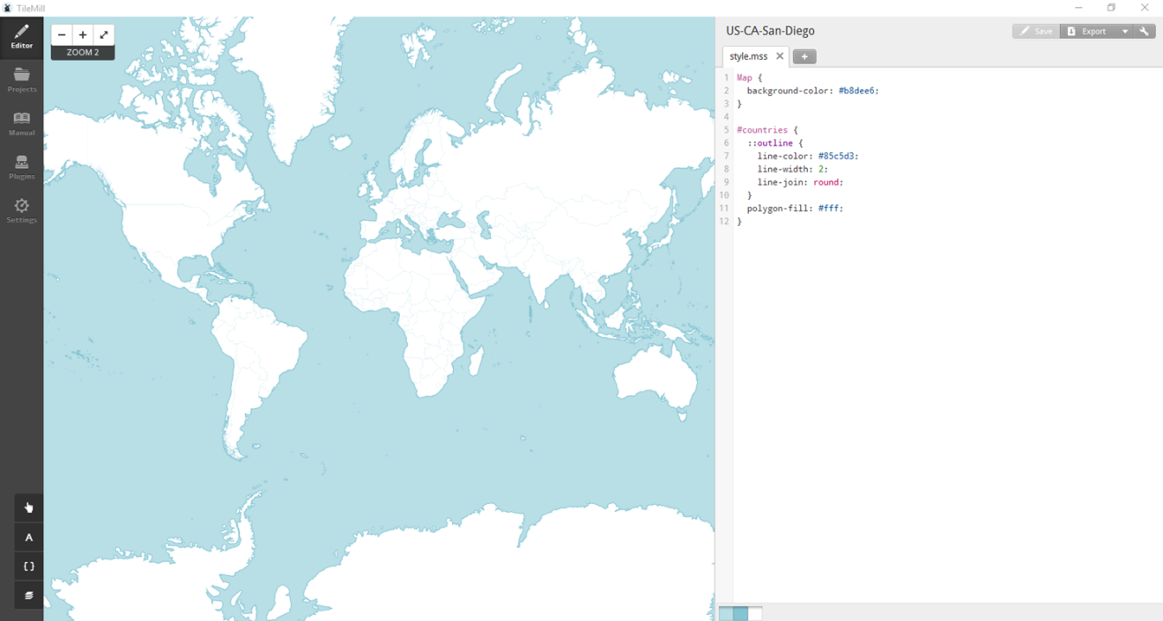

Now you want to add your local data. So you'll be importing the SHP files that you downloaded. Each SHP file is a different type of content. I usually add:

* Water Coast - shows the coastline
* Water Ways - rivers, lakes, etc.
* Aeroways - runways at airports
* Roads - shows roads, parking lots, train tracks and some walkways.

You can also add other ones if you like. For example, one of the SHP files has building outlines.

Each SHP file is added through the layers menu as a new layer. The layer menu is in the lower left corner of the screen. Expand it and click the 'Add layer' button.

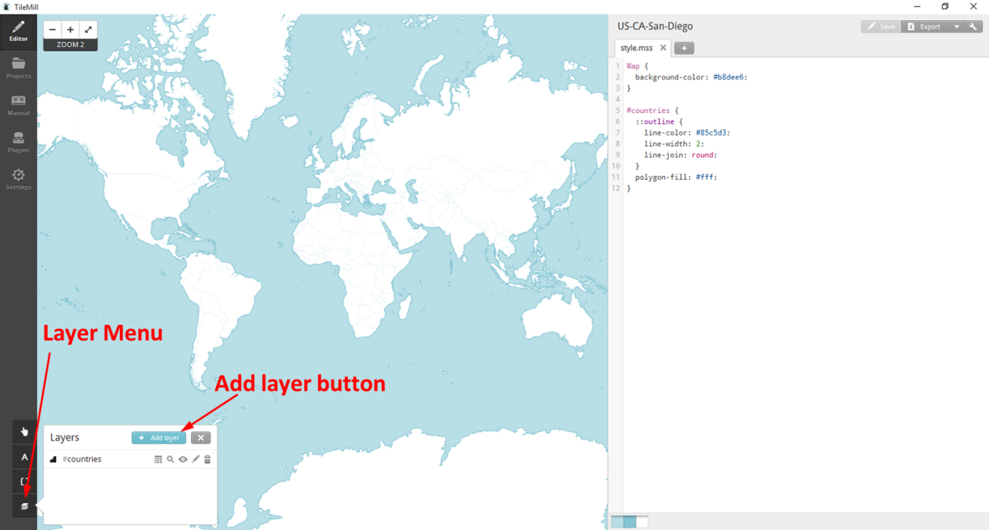

Here's the Add a layer screen. Select the source of your data file. Put in an ID. This is what the added layer will be called, so make it something simple to understand. Then click the Save & Style button. Do not just click the Save button. Save & Style will add formatting to imported layer which will make things easier. We'll discuss formatting more below.

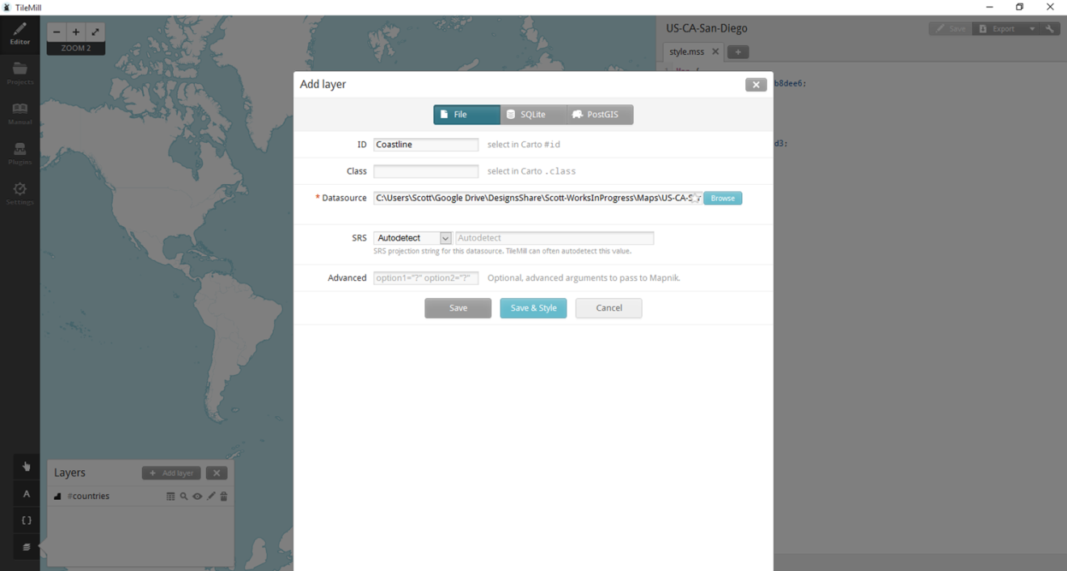

Your data should now be added, but it will be hard to see if you are viewing the whole world. To quickly zoom into your data, click the Layer Zoom icon for the layer you just added.

In the screenshot below, you see the layer has been formatted with fills. Some layers won't have fills; but the coastline one does. For all the laser work we'll be doing, we want the vectors to be lines, not filled. So, its safe to delete the formatting that is creating the fills. In the Style.mss window on the right, you can see the formatting. Each layer's vectors are formatted separately. The hashtag in the .mss file maps to the layer name. You can change colors, line types, thickness, fill, etc. For now, let's just remove the fill for the newly added layer by removing the tow lines that start with polygon. Once you do this, click the save button and the fill should be gone.

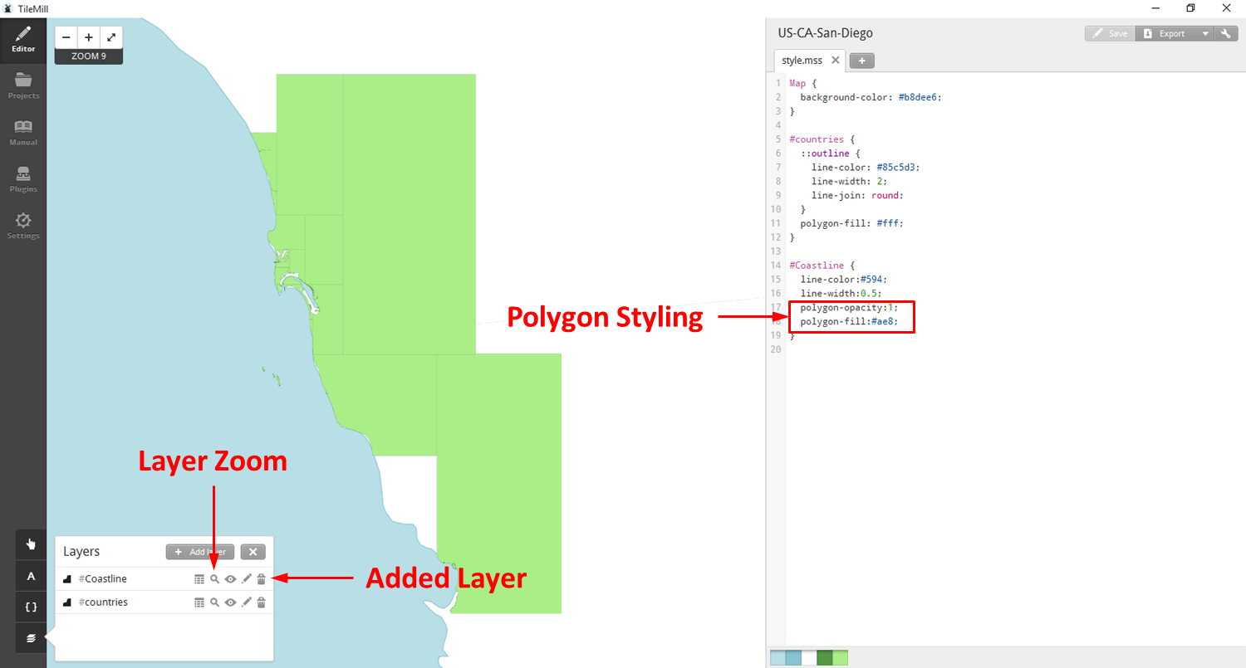

So now, the fill is gone and the map looks much cleaner. But the accuracy of the default world vectors in the countries layer is not that accurate. The coastline vectors are much more accurate. This results in two layers not lining up well at places. So remove this confusion by turning off or hiding the default world vectors. This is done by clicking the Layer On/Off icon in the layer menu for the #countries layer. The result is a much cleaner look map.

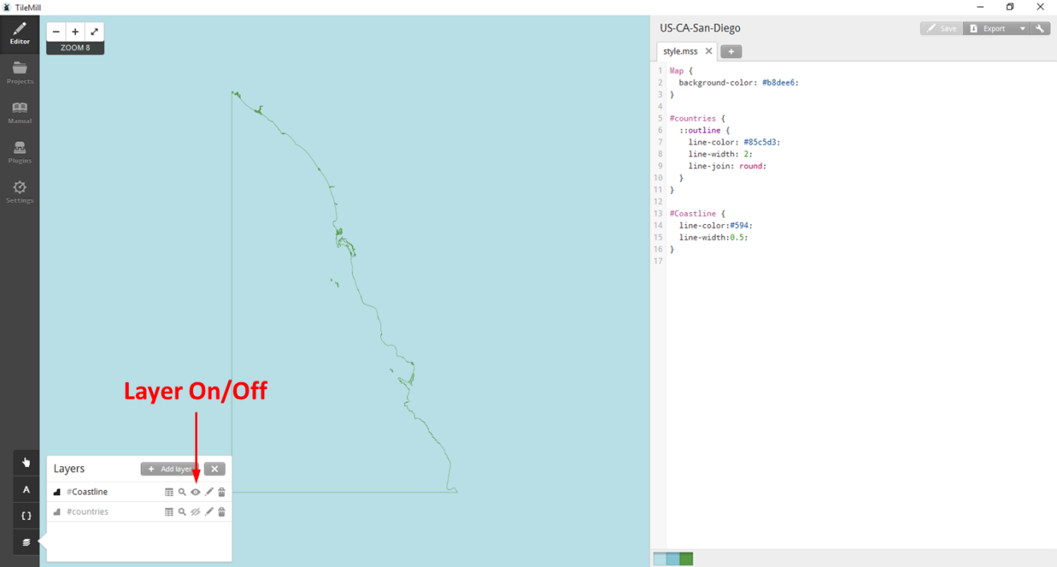

Now you want to add the rest of the layers that you'll use for your map. Just repeat the above steps for each layer that you want to add. You can also adjust the colors and line weights to help visualize the map.

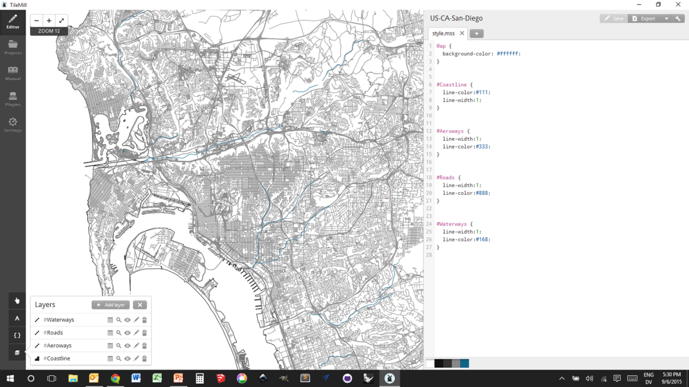

Ok. So now you should have all the data you want on your map loaded up. Now its time to save it to a SVG file. Here's how.

* Click the Export button in the upper left corner and select SVG.
* In the next screen, you define the area that you want to export. The default view is the whole world. So you'll need to zoom in quite a bit to show your map in better detail.
* Once you've zoomed in enough, you'll define the section you want exported by creating a box. You create the box by holding the Shift key and dragging to define the box.
* You can also define the size of the SVG file.
* Then click the Export button.

s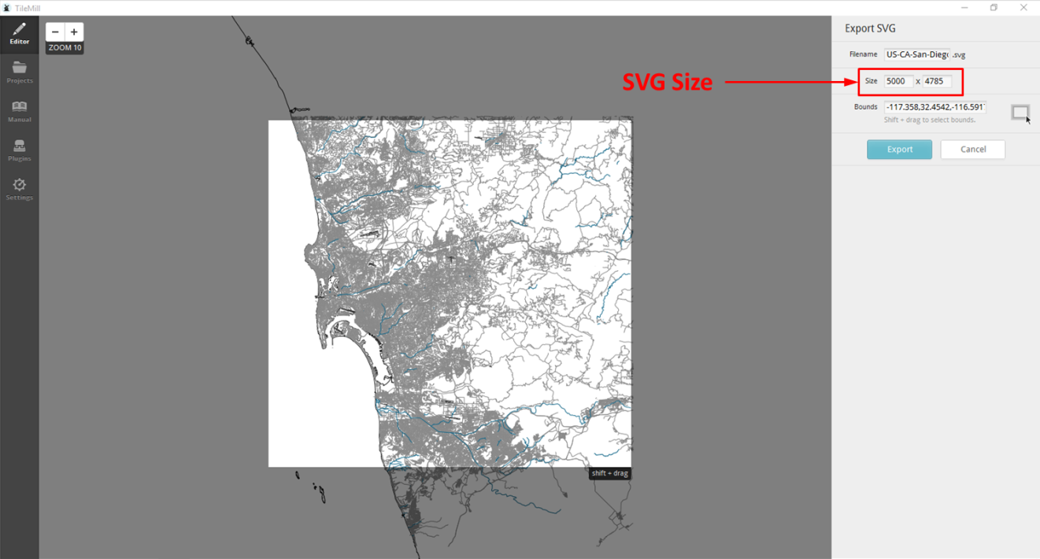

The next screen let's you see all the exports that you have created and save them. Click on the export you just created and select Save.

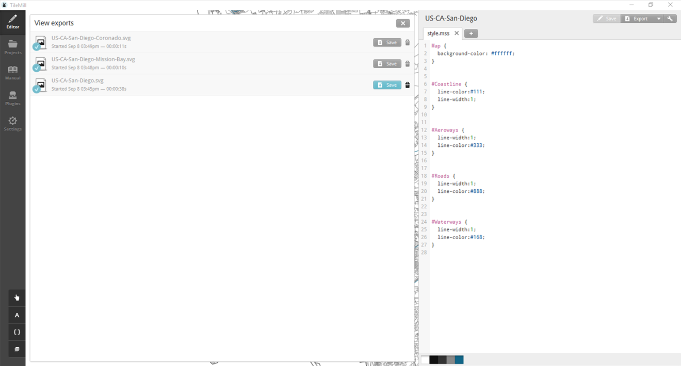

Now, you have a SVG file of your map. You can open it and edit it in InkScape. As you look at your SVG map, you may notice peculiarities with the data. Sometimes the vectors are off or there are too many. This does happen, so you will need to clean it up to meet your needs. Also, in the road data that have used, I find that there is too much information. The road layer also includes parking lots, major walkways and train tracks. This can cause a very cluttered map. I go through and remove the extra vectors that I do not want. This can be a time consuming and manual process. But the effort will produce a better final product. The photo below shows San Diego Sea World. It shows all of the walkways and the lanes in the parking. There is high density of vectors. Printing this on the laser would produce a bit of a mess.

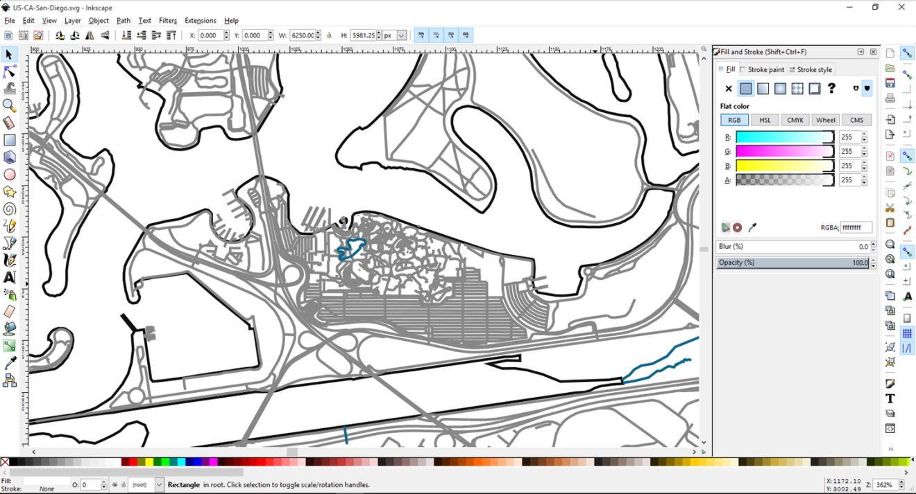

I keep one 'master' file for a city. Then I use that master to create the smaller maps that I print for different areas or neighborhoods.

Now, InkScape doesn't easily allow you to define a smaller area of you master map and trim away the extra vectors. Instead, I do that in CAD software. So I export the SVG from InkScape to a DXF. And then I open it in CAD to create the area I want. I use Rhino for this step. I try to demo on free / open software. But in this case, Rhino is an efficient tool for the work I need to do.

Now that you have the map showing the area you want to show, you can put a border around it or add text as desired. But now its time to do the printing on the laser. Note, that these files have a lot of vectors, so they can take a lot of time to print depending on how large you make the map.

Many people print their maps onto plywood. I also do that. But plywood has its own grain and imperfections that can interfere with the map image. Another option I use is to print onto a white board. Home Depot sells a product that the call Marker Board. It's a 2'x4' sheet of 3/16" MDF that has a whiteboard laminate on one side. Its great for maps. I put application tape on the board before cutting. And I also use Denatured Alcohol to clean it up afterwards where some soiling sneaks in under the application tape. Below you can see photos of maps done on 1/4" maple plywood and Marker Board.

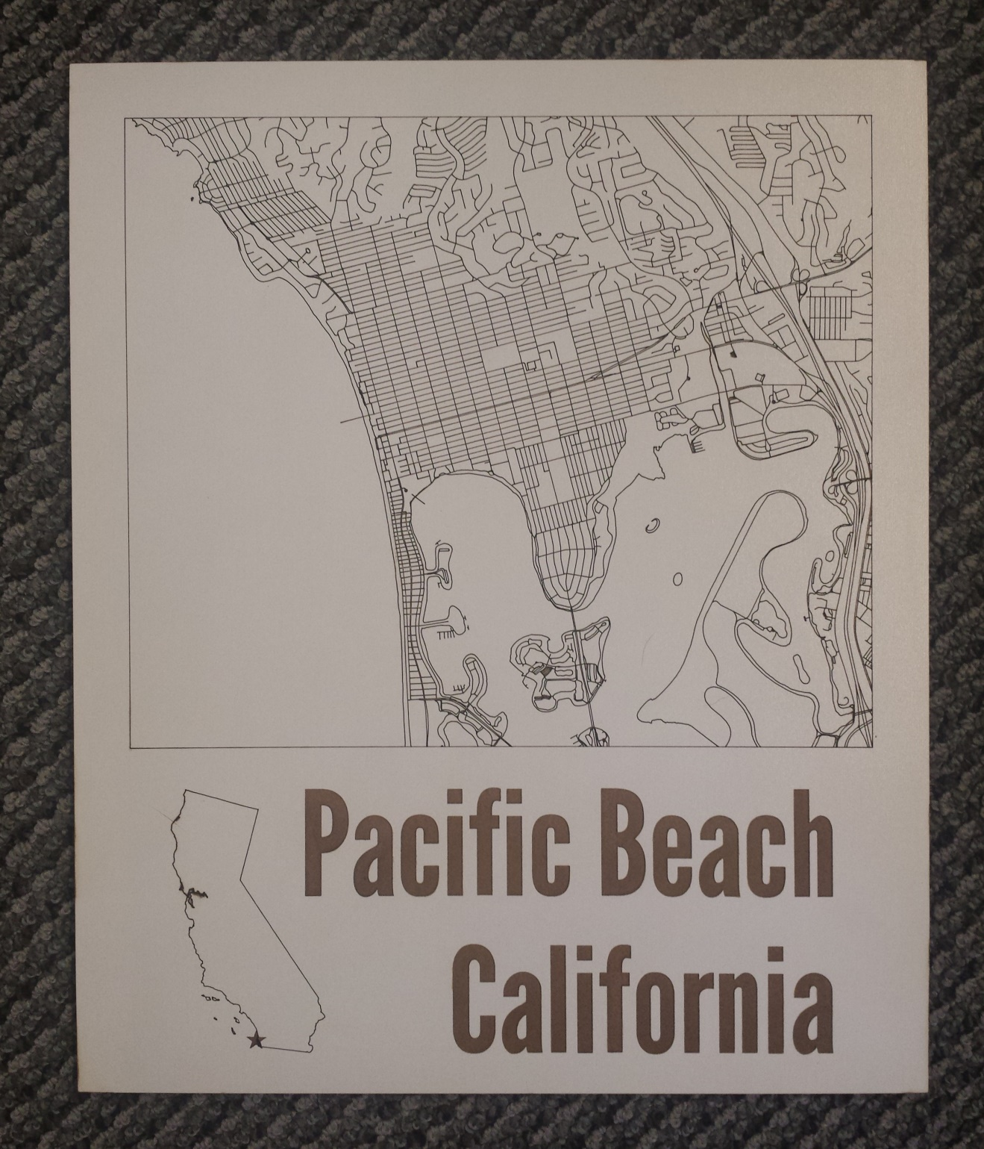

Laser Map on whiteboard

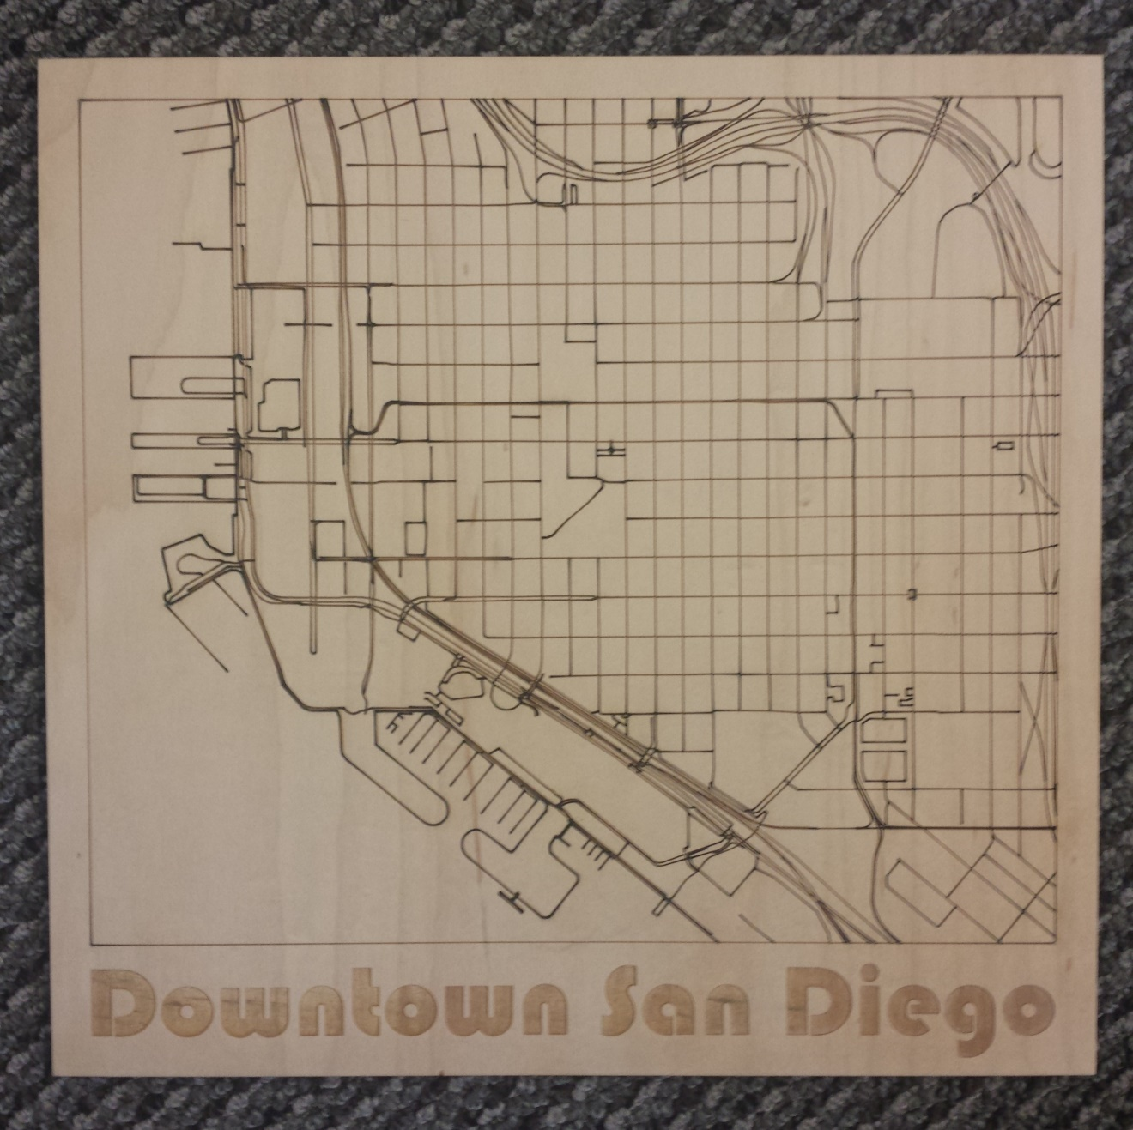

Laser Map in ¼” Maple Plywood

# About Obrary

Obrary is a technology company based in San Diego, California. Obrary is focused on software that automates the digital manufacturing process.

You can visit Obrary on the web at <http://obrary.com>.

## Free, Open Designs

Obrary provides a free library of open designs for products that are made on the laser cutter. See the products at <http://obrary.com/laser>.

